Protokoll zu MikroTik

Eine Skizze zu

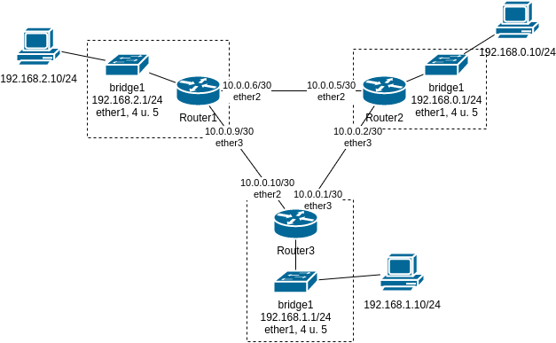

/interface bridge

add name=bridge1

/interface bridge port

add bridge=bridge1 interface=ether1

add bridge=bridge1 interface=ether4

add bridge=bridge1 interface=ether5

/ip address

add address=192.168.2.1/24 interface=bridge1 network=192.168.2.0

add address=10.0.0.6/30 interface=ether2 network=10.0.0.4

add address=10.0.0.9/30 interface=ether3 network=10.0.0.8

/ip route

add distance=1 dst-address=10.0.0.0/30 gateway=10.0.0.5

add distance=1 dst-address=192.168.0.0/24 gateway=10.0.0.5

add distance=1 dst-address=192.168.1.0/24 gateway=10.0.0.10

distance

/interface bridge

add name=bridge1

/interface bridge port

add bridge=bridge1 interface=ether1

add bridge=bridge1 interface=ether4

add bridge=bridge1 interface=ether5

/ip address

add address=192.168.2.1/24 interface=bridge1 network=192.168.2.0

add address=10.0.0.6/30 interface=ether2 network=10.0.0.4

add address=10.0.0.9/30 interface=ether3 network=10.0.0.8

/ip route

add distance=1 dst-address=10.0.0.0/30 gateway=10.0.0.5

add distance=10 dst-address=10.0.0.0/30 gateway=10.0.0.10

add distance=2 dst-address=192.168.0.0/24 gateway=10.0.0.5

add distance=3 dst-address=192.168.1.0/24 gateway=10.0.0.10